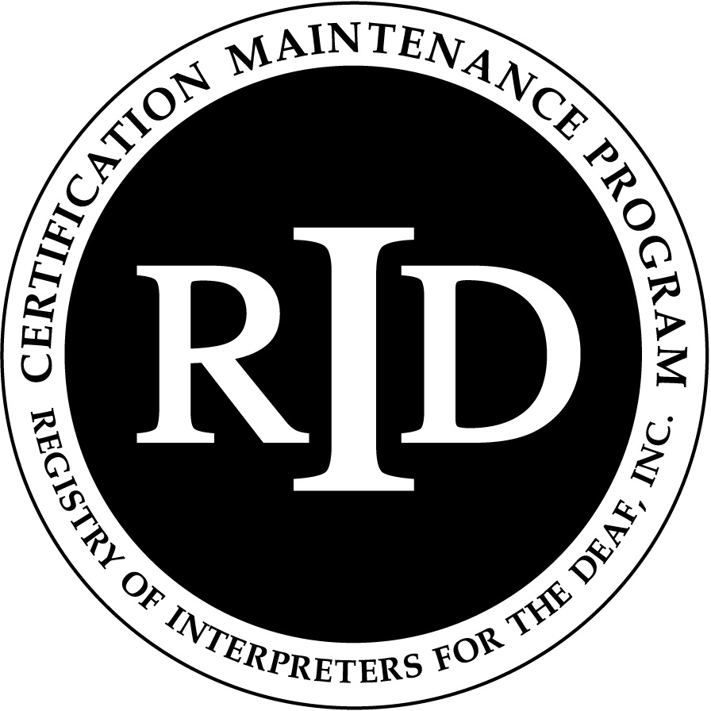 **Academic Coursework Activity Report**



**for Courses at Accredited Colleges and Universities**

Note to participant:

This activity form must be submitted to the RID Approved Sponsor upon completion of the academic course.

A copy of the description of the course and the Institution’s transcript or grade report should be attached. The Sponsor will file the paperwork online at www.rid.org for CEU processing at the RID national office.

CMP Participant Name (print):_**________**_____________________ RID Member #: _**_____**______________

CMP Participant Address _**__________________________________**_____________________________________

CMP Participant Email _**______________________**______ Phone #_**___________**__________________________

CMP Participant Cycle End Date_**__________**________________________________________________________

Course Title: _**____________________**_____________________________________________________________

Name of College or University_**_______________________**____________________________________________

What is the number of credit hours assigned to the course? _______/semester or _____/quarter

Name of Approved Sponsor: _**New York City Metro RID**________________________________________

RID Activity Number for this Academic Coursework:

**___ ___ ___ ___.___ ___ ___ ___.___ ___** _______________________

Sponsor Code Month Year Ascending within month; Internal Code (optional)

To which CMP *Content Area* does this course apply? Professional Studies ___**_**___ General Studies ______

Course Start Date: ______________________ Course Completion Date: _________________

Number of Continuing Education Credits* (CEUs) awarded to CMP participant: ___**___**___

(*1.5 CEU/credit based on a *Semester* session or 1.0 CEU/credit based on a *Quarter* session.

As a CMP participant, I certify that this academic coursework represents a valid and verifiable Continuing Education experience which exceeds routine employment responsibilities.

Signature of CMP Participant _________________________________________________Date ________________

As the CMP Approved Sponsor for this Academic Course activity, I have verified successful completion of the course and a grade of “C” (2.0 GPA) or better and the course was taken at a accredited institution recognized by the Council for Higher Education Accreditation (CHEA).

Signature of RID Approved Sponsor Administrator _______________________________Date ________________

Updated January 2008