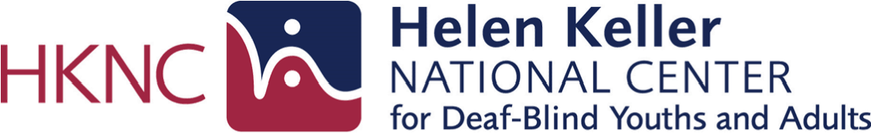
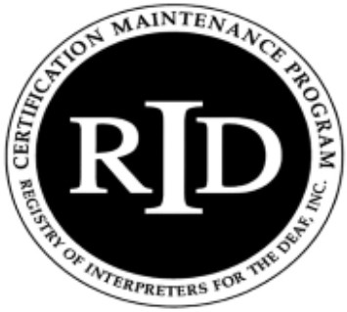
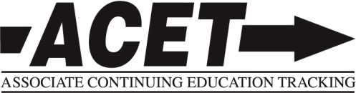
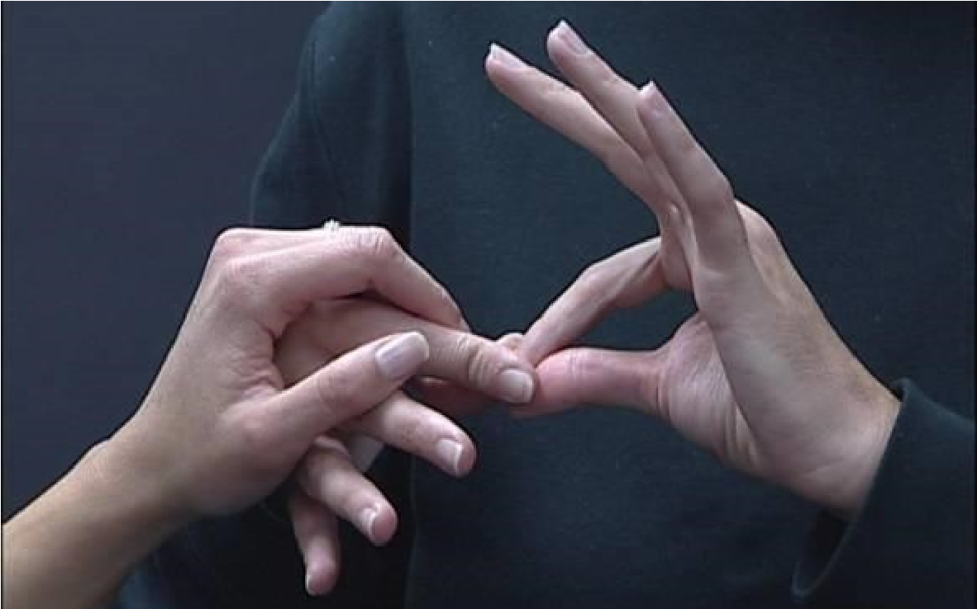

Ensuring Access to Communication for

Individuals who are Deaf
-
Blind

P
ROFESSIONAL

T
RAINING

S
EMINAR

FOR

S
IGN

L
ANGUAGE

I
NTERPRETERS

Participants will gain knowledge, skills, and experience in the following areas:

•

Common etiologies and visual conditions related to deaf
-
blindness.

•

An understanding of how they can use this information to better meet the needs of their
consumers.

•

Communication strategies and accommodations to ensure equal access for individuals who have a
combined vision and hearing loss.

•

Human guide techniques.

•

Technology used in the interpreting process.

•

Deaf
-
blind culture.

•

The role of the Support Service Provider (SSP).

•

Providing visual and environmental information using various methods, including touch signals.

2.2
CEU credits provided at

completion of on
-
site training.

COST: $300: Includes online and on
-
site

training, training materials, and lunch daily.

A Two
-
Part Hybrid Course

Part I (online) 2/27/18
-

18
/13/
3

Part II (onsite) 3/15/18
-

18
/16/
3

Led by Deaf
-
Blind Professionals and

HKNC Interpreting Staff

Information, Research & Professional Learning Department & Interpreting Department

HKNC
●

141
Middle Neck Rd
●

Sands Point, NY 11050
●

516
-
944
-
8900

Register
now! Space is limited.

Applications and payment must be received by February 1, 2018

DETAILS AND MORE INFORMATION
LOCATION: The seminar will be held in the Leona and Harry B. Helmsley Conference Center on the campus of the Helen Keller National Center, a beautiful 25 acre facility in Sands Point, Long Island, NY. The Center is convenient to most NYC area airports. Lodging is available on campus on a first come/ first served basis. Please contact Cindy Witkow at 516-944-8900 ext. 233 for rates and information.

REGISTRATION REQUIREMENTS: This course is for interpreters who are currently working or plan to work with individuals who are deaf-blind.

COURSE INFORMATION: Online: February 27– March 13, 2018 and On-Site: March 15-16, 2018

COST: $300 — Includes online training and two days of on-site training, training manual, and daily lunch. Lodging is available on campus on a first come/first served basis and all rooms are double occupancy. Please contact Cindy Witkow at 516-944-8900 ext. 233 for lodging rates and information. Residence Check-in available Wednesday, March 14, 2018 and Check-out at 8:00 am on Friday, March 16, 2018.
CEU INFORMATION: This workshop will offer 2.2 RID CEUs or ACET credits in the Content Area of Professional Studies and has a Content Knowledge Level of little/none knowledge.
This intensive and interactive seminar will prepare interpreters with the skills and knowledge necessary to effectively meet the needs of deaf-blind consumers. Our hybrid approach of combining an online preseminar with onsite training enhances the learning process and makes the most efficient use of participants’ time with their trainers. The trainers include interpreters who have been working with the deaf-blind community for 20 + years, as well as deaf-blind professionals employed in the field, all of whom will be sharing their expertise and personal perspectives. Participants will walk away from this seminar with a strong working knowledge of the common etiologies and visual conditions related to deaf-blindness and an understanding of how they can use this information to better meet the needs of their consumers. They will learn various communication strategies and accommodations to ensure individuals with combined vision and hearing loss have equal access to communication. Additional topics that will be addressed during this training include; human guide (techniques), technology used in the interpreting process, deaf-blind culture, the role of the support service provider (SSP), and providing visual and environmental information using various methods, including touch signals.

Cancellation Policy upon Request from Helen Keller National Center
Request for reasonable accommodations information provided upon request.
Applications and payment must be received by February 1, 2018
Send payment to: Professional Learning Department Information: PLD@hknc.org
Helen Keller National Center Phone: 516-944-8900 ext. 233
141 Middle Neck Road www.helenkeller.org/hknc
Sands Point, NY 11050
2
Registration: https://www.helenkeller.org/sites/default/files/docs/application_2016_docrev.pdf (PDF)
https://www.helenkeller.org/sites/default/files/docs/application_2016_docrev.txt (accessible version)

